Rules

Colorectal cancer

Main symptoms

* **change in bowel habit**
* **blood in the stools**
* **abdominal pain**

However these symptoms can are common and are not usually a sign of colon cancer. They become more significant if a patient is in there sixties and the symptoms persist even with treatment.

“Colorectal cancer was a common cancer diagnosed during 2000-2004 with approximately 52 people in every 100,000 diagnosed with the disease each year. On average there were 1,618 male and 1,297 female cases diagnosed annually contributing 14.7% of male and 12.3% of female cancers (excluding NMSC) in Ireland. It was the second most common male and female cancer although the risk of developing the disease before age 75 was higher among males with a 1 in 20 risk for males and 1 in 32 risk for females. (Tab. 8.1)”.

“European age-standardised incidence rates (EASIR) for colorectal cancer were higher among males than females.”

“While colorectal cancer was diagnosed mainly among the elderly with a median age at diagnosis of 71 during 2000-2004, 5.9% of all male and 7.8% of female colorectal cancers were diagnosed among those aged under 50.”

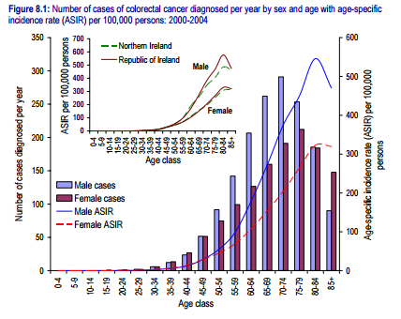

<http://www.qub.ac.uk/research-centres/nicr/FileStore/PDF/Filetoupload,185612,en.pdf>

Findings

* Men are more at risk of colon cancer than women (however women at still at risk).
* Supports NHS stance that age is contributing factor in a person’s likely hood to have colon cancer.
* The chart shows that colorectal cancer only starts to become a concern after the person is over 39 and is unlikely before this.

**Colorectal cancer rules**

Men than women – (1,618 male and 1,297 female) 55.5% men and 44.5 women% meaning men 11% more likely than women. For obvious reasons it can’t be set that once the system know that patient is a men that it thinks 11% likely to have colorectal cancer without any symptoms.

Also age is a factor as the older the patient is the higher their risk. However age and should come into account after symptoms are mentioned so

An if statement checking which symptoms are mentioned then an nested if statement which checks what age and gender they are then set the percentage from this. If the symptoms are persisted will be factor as well but because this system is designed to catch Illness in their early stages its more likely that if a symptom is persisted the doctor will have already noticed this and could already have the same concerns.

40 to 49 = 25 (4%);

50 to 59 = 50 (8%);

60 to 69 = 150 (24%);

70 to 79 = 250 (40%);

80+ = 150 (24%);

625

Lung cancer

Main

* a persistent cough
* coughing up blood
* persistent breathlessness
* unexplained tiredness and weight loss
* an ache or pain when breathing or coughing

“Lung cancer mainly affects older people. It is rare in people younger than 40, but the rates of lung cancer rise sharply with age. Lung cancer is most commonly diagnosed in people aged 70-74 years.”

<http://www.nhs.uk/conditions/cancer-of-the-lung/pages/introduction.aspx>

“There were on average 1,599 male and 1,016 female cases of lung cancer diagnosed each year in Ireland during 2000-2004.”

“In Ireland there were on average 1,599 male and 1,016 female cases of lung cancer diagnosed each year between 2000 and 2004, making it the third most common male and female cancer diagnosed and the fourth most common cancer overall (behind breast, colorectal and prostate cancer).”

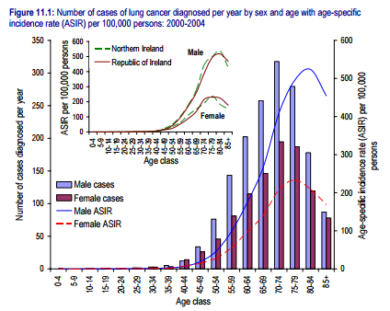“The median age at diagnosis for patients with lung cancer during 2000-2004 was 71”.

<http://www.qub.ac.uk/research-centres/nicr/FileStore/PDF/Filetoupload,185612,en.pdf>

Findings

* Men are more likely to get lung cancer than women and from the statement “There were on average 1,599 male and 1,016 female cases of lung cancer diagnosed each year in Ireland during 2000-2004.” It seems that men are over third more likely to get lung cancer.
* However, lung cancer is rising in females and decreeing in males.
* It was the third most common cancer diagnosed.

1,599 male and 1,016 female

62% male

38% females

24% difference

40 to 49 = 25 (2.7%)

50 to 59 = 150 (16.2%)

60 to 69 = 250 (27%)

70 to 79 = 300 (32.4%)

80 and over = 200 (21.6)